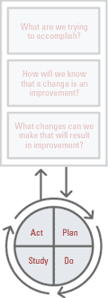
PDSA Planning Worksheet

Plan:
- What is the objective of this improvement cycle? (Why) ________________________________________________________________________________________________________________________________

- Predictions:
__________________________________________________________________________________________________________________________________

- Plan for change: (who, what, when, where) ______________________________________________________________________________________________________________________________________________________________________________________________________

- Plan for collection of data: (who, what, when, where)
______________________________________________________________________________________________________________________________________________________________________________________________________

Do:
- Carry out the plan. Adjust the plan if necessary. Record any adjustments to the plan.
______________________________________________________________________________________________________________________________________________________________________________________________________

Study:
- How did or didn’t the results of this cycle agree with the predictions that were made earlier?
______________________________________________________________________________________________________________________________________________________________________________________________________

- List the new knowledge gained by this cycle:
______________________________________________________________________________________________________________________________________________________________________________________________________

Act:
- List actions taken as a result of this cycle. Internalize the new process if results were positive. Adjust the process and begin PDSA again if results were not as desired.
______________________________________________________________________________________________________________________________________________________________________________________________________

